RE/Visa request

**128th Session of the UIA Council**

**Dar es Salaam, Tanzania, 31st March-1st of April 2016**

Name:   Mr. Zhang Baiping, alternative UIA Council member and Deputy Secretary General of ASC-Architectural Society of China

Paris, 26th February 2016

VISA DECLARATION

We hereby declare that Mr. Zhang Baiping, alternative UIA Council member and Deputy Secretary General of ASC-Architectural Society of China, will participate in the 128th Session of UIA Council to take place from 31st March-1st of April 2016, in Dar es Salaam, Tanzania.

Please be so kind as to facilitate the necessary Visa formalities in order to ensure his presence in Dar es Salaam at the dates indicated above.

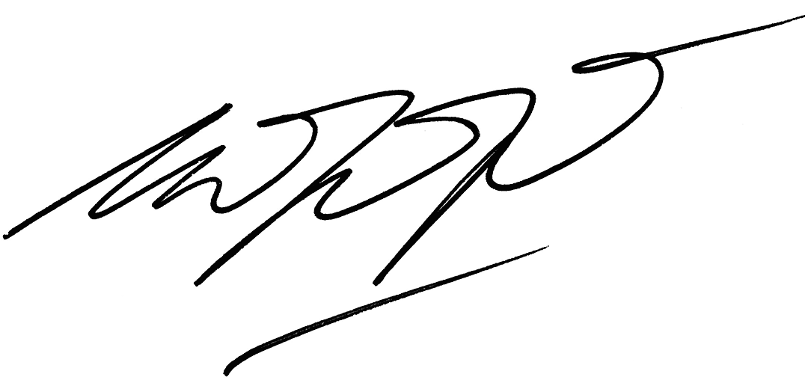

Esa Mohamed

UIA President